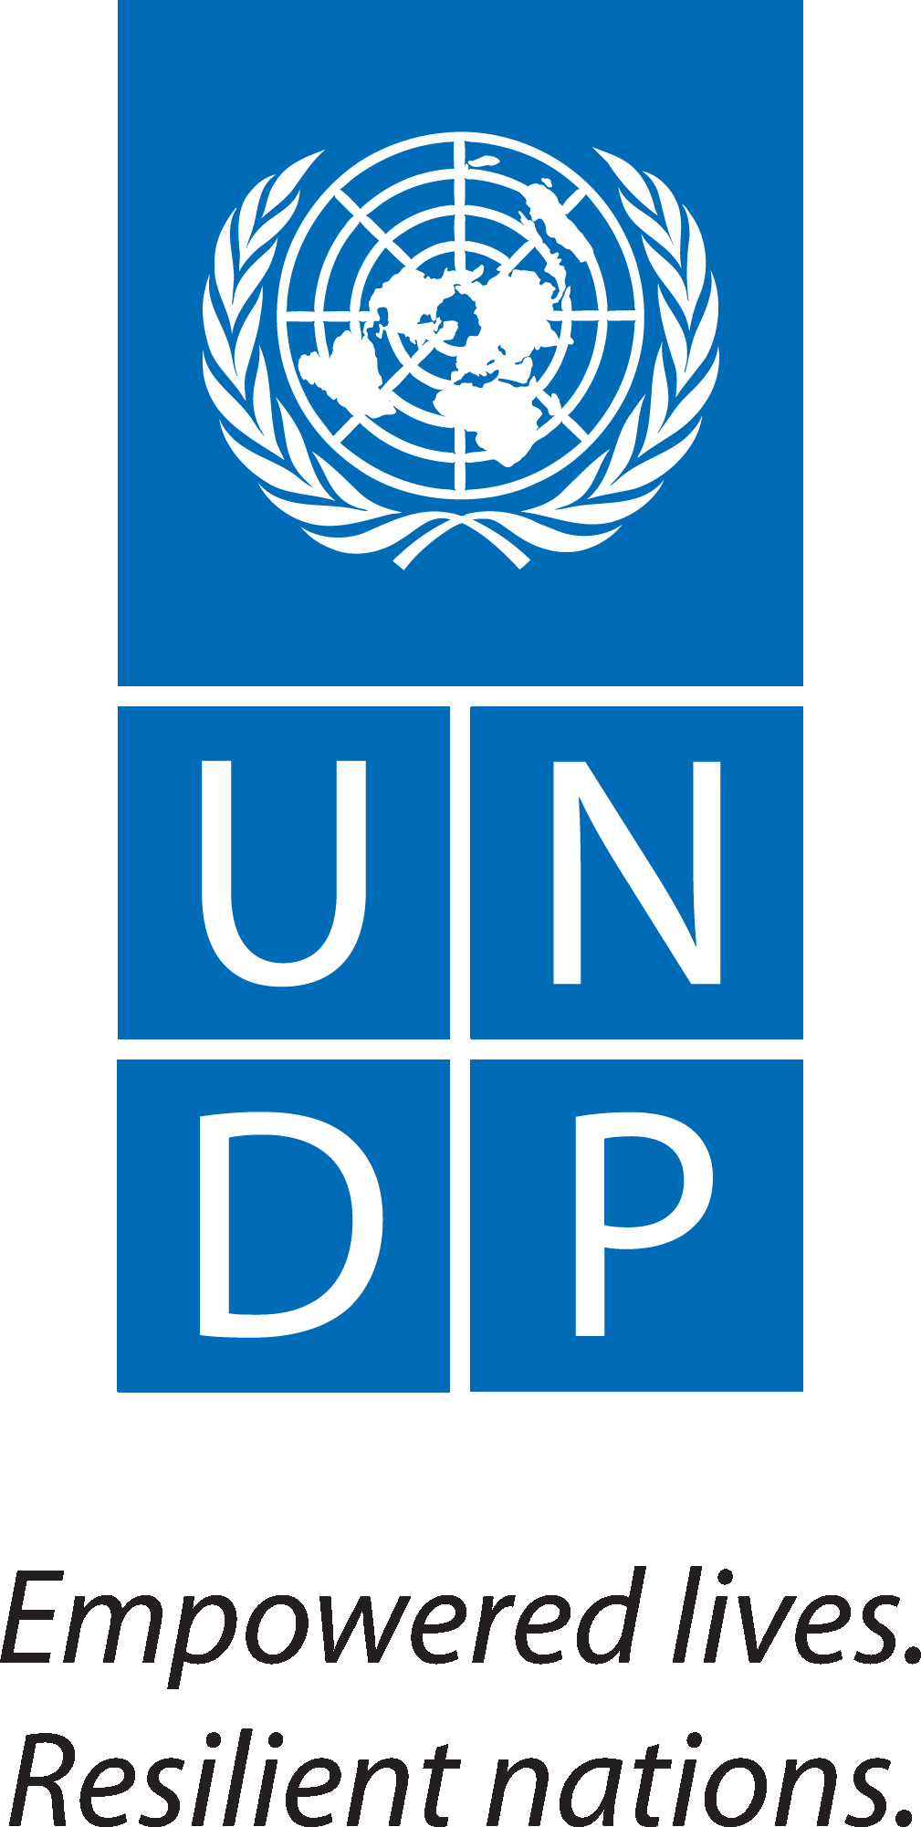

Report on Procurement Support Mission S4H Namibia
December 2017

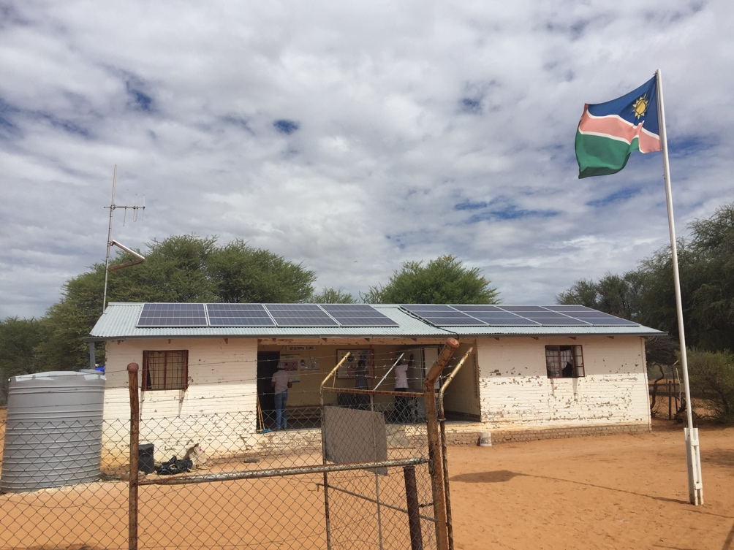
Uutsathima Clinic, Omusati Region - Namibia

Crisis Response, Energy and Environment Team
Procurement Services Unit (PSU) | Bureau for Management Services (BMS)
United Nations Development Programme
Namibia: Country Brief

Namibia is favoured with substantial solar, wind and biomass resources. These renewable energy resources constitute a comparative national advantage that the country can use to its long-term socio-economic benefit. Greater Namibia receives solar radiation of 5.8 – 6.4 KWh per square meter per day, amongst the highest in the world. With 8 – 10 average hours of sunshine per day throughout the year, this presents fantastic potential for solar power. It is worth noting that, in general, there have been a number of commendable developments in the area of renewable energy systems in Namibia in the past several years.

- Namibia solar irradiation levels are quite high at 3000 kWh/m2 over a large part of the country.
- Development of a national Renewables Energy Policy is in progress.
- Net Metering rules developed. Net Metering being a billing arrangement with the utility to allow customers with Solar PV systems to receive credit for excess renewable electricity delivered to the grid.
- Recently NamPower has also been involved in procurements related to large/utility-scale projects.

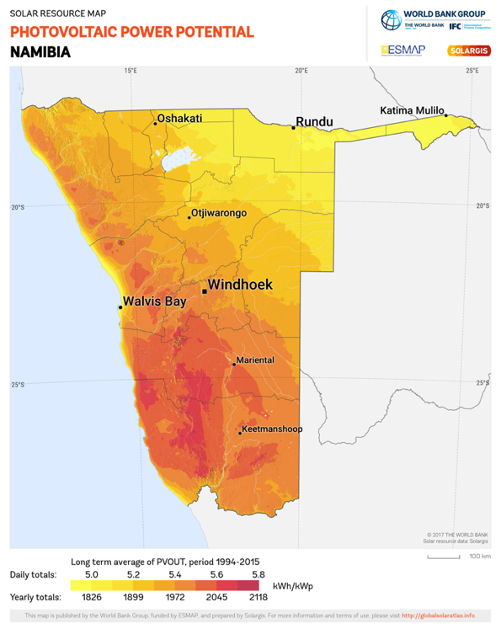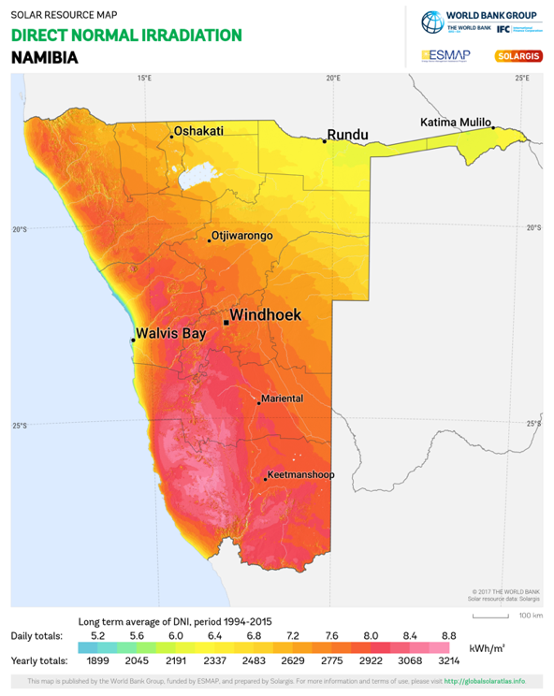
Source: Solargis - Solar Resource Maps of Namibia
https://solargis.com/products/maps-and-gis-data/download/namibia

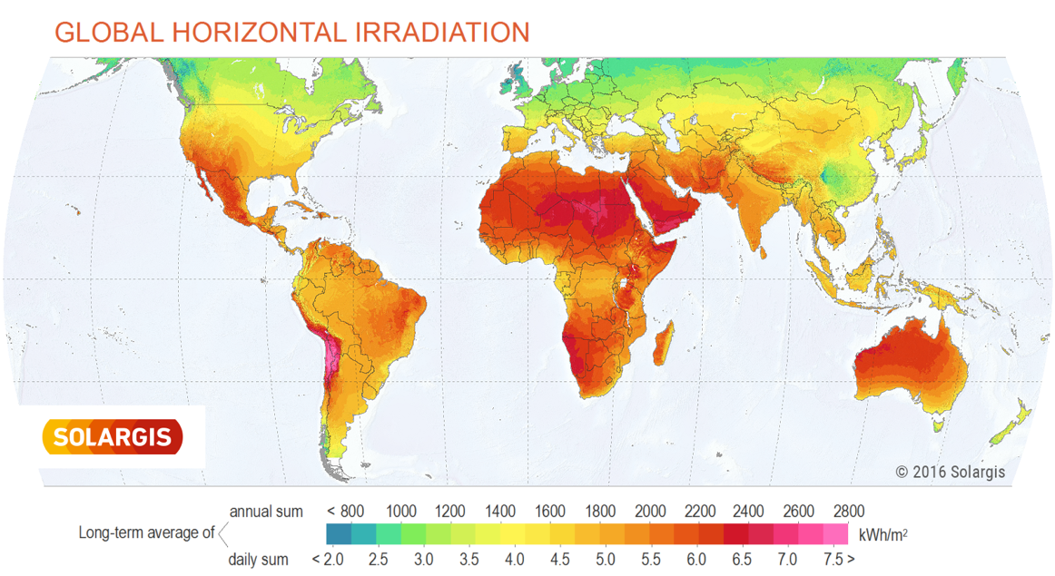
Source: Solargis – Global Horizontal Irradiation
https://solargis.com/assets/graphic/free-map/GHI/Solargis-World-GHI-solar-resource-map-en.png
The opportunity to dramatically enhance use of renewable energies and/or technologies to contribute to Namibia’s development is apparent.

Background

United Nations Development Programme (UNDP) Namibia partnered with the Global Fund; Ministry of Health and Social Services under the UNDP’s global initiative dubbed Solar 4 Health (“S4H”).

Led by UNDP Namibia, the partnership undertook a pilot project to commission Solar Photovoltaic (PV) Systems at five clinics across Namibia in December 2017.

The project was support by Global Fund with regards to funding. These systems will provide constant and cost-effective access to electricity and therefore assist in providing rural communities with reliable and sustainable power solution. The related medical facilities are better equipped to provide essential health services to the surrounding communities.

This project will play a part in bringing Namibia one step closer to achieving the Sustainable Development Goals (SDG’s) 3, 7, 13 and 17 that call for good health and well-being, affordable and clean energy, climate action and partnerships respectively. These are particularly attained in relation to the Solar 4 Health project.

Under this pilot project, 5 clinics were equipped with 6kWp solar systems and these include:

- Okaukamasheshe
- Uutsathima
- Eiseb
- Klein Aub
- Kalkrand

Objectives

With a view to enhance the pilot project, UNDP Namibia engaged the support (mission) of UNDP/PSU to provide management support in the implementation of the solar systems at the related five health facilities across Namibia. Related support also including project management, procurement services, etc.

The following section(s) provide an overview of the mission and successful implementation of the pilot project.

Deliverables

In order to deliver the objectives of the mission a systematic and practical approach was undertaken which included but was not limited to successful completion of the below summarised milestones:

- Coordination, monitoring and evaluation in the in-land distribution, installation and commissioning of the Solar PV systems at related clinics.
- Travel and on-site visit of each of the 5 locations to undertake systems verification and acceptance testing.
- Coordination and resolution of any procurement or logistical issues arising from the delivery of the Solar PV systems as well as liaising with site and regional focal contacts.
- Ensure timely and transparent supply chain process.
- Facilitation of knowledge building and sharing with Health Facility and UNDP/CO focal contacts.
- Presentation of PSU to related focal contact(s) including Ministry of Health regarding UNDP corporate procurement services.

The following provides a list of the associated clinics; their location and short description of implemented solution:

- 6kWp Off-Grid or Grid Connected solar PV systems inclusive of 24kWh battery bank
- Annual 2-Year Preventative Maintenance visit by GSOL Energy’s local partner (SolTec c.c.)

# | Name of Heath Facility | Remarks
 | Eiseb Clinic,  Omaheke Region | Off-Grid solar PV system.  No local grid and no functional diesel generator.
 | Kalkrand Clinic,  Hardap Region | Grid-Connected solar PV system.  Local grid generally available (outages usually experienced during difficult weather).
 | Klein Aub Clinic,  Hardap Region (replaced Rehoboth Health Centre) | Grid-Connected solar PV system.  Local grid generally available (outages usually experienced during difficult weather).
 | Okaukamasheshe Clinic, Oshana Region | Grid-Connected solar PV system.  Local grid generally available (outages usually experienced during difficult weather).
 | Uutsathima Clinic,  Omusati Region | Off-Grid solar PV system.  No local grid and no functional diesel generator.

Further details are available via the below listed/additional supporting documents:

- Final Acceptance and Compliance Testing
- Site Installation Photos
- System and Operation Guide
- Preventative Maintenance and Warranty Overview

Lessons Learnt

The following provides summary of some lessons drawn from implementation of S4H Namibia Pilot project but also from previous similar projects. As such the below is included with a view to inform and benefit potential future and the pilot projects.

- The value and potential of solar PV systems or renewable energy technologies is vast. Within this pilot project, this aspect is certainly demonstrated by the examples of Eiseb and Uutsathima Clinics that have had no electricity, but now, thanks to solar PV systems are able to offer enhanced service to the communities they serve. Essential medication including vaccines can will now be refrigerated and stored at location rather than at Regional Hub located within couple to a few hours away by road.

- The involvement of the beneficiary together with the Public Infrastructure Ministry and the related regional/local infrastructure support including final end-user(s) is essential. This is important to ensure appropriate support in the identification of health facilities including requirements, implementation and upkeep of the systems in order to draw maximum benefit of the investment and systems in a sustainable manner.

- While a standardised approach is beneficial in several aspects, based on this Namibia S4H Pilot and other similar projects, it is apparent that each health facility or clinic often has individual needs and specificities in terms general or technical elements. In this regard and ahead of finalising procurement, advance Site Survey of affected facilities would highly beneficial to the overall success of the project. The survey would enable verification of particular site elements/conditions including confirmation of final requirements ahead of implementation in terms of logistics; technical or functional requirements.

- During the implementation of the project it was realised that the available (pre-sized) solar PV system, was much undersized in relation to one of the initially intended facilities: Rehoboth Health Centre.
The same situation applied to nearby alternate: Rehoboth Clinic, which was also well equipped with a large size backup diesel generator capable to provide that clinic’s energy demand/load during local grid outages. A third facility (i.e. Klein Aub Clinic) was identified. The mission verified and confirmed its energy requirements to be within the capacity of the available solar PV system. As such the system was successfully installed and commissioned at this third facility. While the outcome was positive, this experience reaffirms the value for advance site surveys.

- The procured systems are inclusive of 2-year preventative maintenance support. In order to ensure upkeep and long-term sustainability of the systems, it will be essential for the relevant end-user ministry to consider and/or follow-up on extending maintenance support arrangements beyond the 2-year period included with system purchase, not only to maximize benefit of the investment but also to reduce risk of system failure etc.

- Users are often unaware of the proper operation, care, or limitations of systems. Initial systems training should be complimented by regular interval in-house initiatives including the enhancement of internal operations and maintenance protocols to ensure success of related PV systems.

- When selecting beneficiary health facilities, it is recommended that stakeholders consider the following clarify question and functional priority of solar system:

What is the priority with regards to providing renewable energy?

# | Functional Priority | Potential Benefit
 | Facilities without both local grid or generator. | Energy Access. Enhanced service provision to communities.
 | Facilities whose energy source is only diesel generator. | Reduce high dependency of fuel, cost of upkeep and dirty energy source
 | Facilities with regular local grid. | Reduce the expenditure on electricity bills.

Imbedded within the above 3 functional priorities is the principal of clean/renewable energy for related health facility.

Conclusion

The Solar PV Systems have been successfully implemented and continue to provide sustainable energy to the related health facilities. Through this pilot Namibia is one step closer to achieving the SDGs’ 3, 7, 13 and 17 that call for good health and well-being, affordable and clean energy, climate action and partnerships respectively.

On the other hand, this project is in line with the World Health Organisation's (WHO) Operational Framework for building climate resilient health systems highlights the need to take a broad approach mediate the challenges of climate change, including a focus on renewable energy in health facilities and utilizing innovative technologies.

In conclusion UNDP/PSU is delighted to have contributed to this significantly important partnership and project. We anticipate that the value of this project will be well recognised and the pilot will grow to provide sustainable energy to numerous more health facilities (beyond the current 5 clinics).
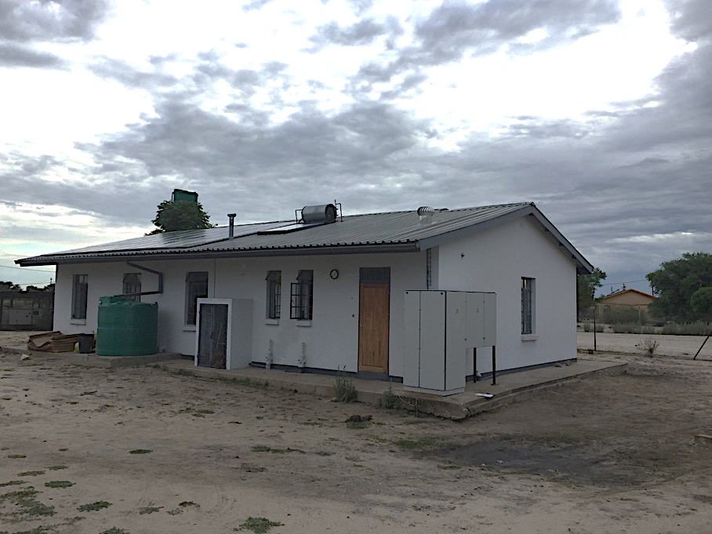
Eiseb Clinic, Omaheke Region – Namibia

